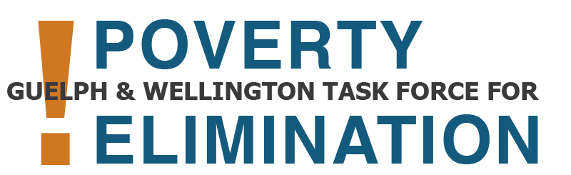 | Community Advocacy Training  with the Poverty Task Force
Expression of Interest Form

Please complete this form by 4:30pm on Friday, April 28, 2023 if you wish to be considered for the Poverty Task Force’s Community Advocacy Training. All forms will be reviewed. You will be notified regardless of whether or not you have been selected. Please submit your expression of interest to Dania El-Ayoubi by email (dania@gwpoverty.ca) or reach out to Dania if you have questions, would like support to review or fill out the form, or to express interest in a different way.

What is the Poverty Task Force’s Community Advocacy Training?

It is a no-cost six-week training program for up to ten people from Guelph and Wellington who have experience living with low income and are interested in advocating on poverty issues.

Participants will attend training sessions on a number of topics, such as:
- Advocacy
- Storytelling
- Talking with media
- Meeting with elected officials

The program will support participants to develop new skills and build on the skills they have to:
- Increase awareness of poverty experiences
- Advocate for solutions
- Grow relationships

When training is done, participants will have the chance to advocate in settings such as:
- Community meetings
- Advocacy meetings
- Outreach activities
- Events and more

Who can participate in the training?

You can apply to this program if you:
- Live in Guelph or Wellington County
- Have direct experience living on low-income
- Are interested in advocating on poverty issues, such as:
  - Decent work (example: low wage work)
  - Income insecurity (example: living on social assistance or other income benefits)
  - Housing issues and homelessness
  - Food insecurity
  - Health issues (example: not able to afford dental care or medication)

When does the training start and where will it take place?

Training runs every Tuesday for six weeks (May 16th to June 20th). The sessions are on:

- Tuesday, May 16th, 9:00am-2:00pm: Session 1: Introduction and welcome
- Tuesday, May 23rd, 9:00am-12:00pm: Session 2: Anti-oppression training
- Tuesday, May 30th, 9:00am-12:00pm: Session 3: Storytelling
- Tuesday, June 6th, 9:00am-12:00pm: Session 4: Public speaking & media relations
- Tuesday, June 13th, 9:00am-12:00pm: Session 5: Advocacy & government relations
- Tuesday, June 20th, 9:00am-2:00pm: Session 6: Putting skills into action & closing

On Friday, June 16th from 9am-11am, participants will have an opportunity to attend a Poverty Task Force Member Committee Meeting to share their experience with the program.

Community Advocacy Training is in person. It will take place in a physically accessible location that can be accessed by transit. Details will be sent out once participants are confirmed.

Individuals who may not be available during the above times are still encouraged to apply indicating their availability as training times may change.

Honorarium and participation supports:

Participants will be provided with an honorarium for their participation in Community Advocacy Training for up to 25 hours. Participants can choose to have the honorarium paid in cash or by cheque. Additional participation supports (example: transportation, childcare, technology support, etc.) will be provided as needed.

1. Please fill out this section with your contact information:

First name(s): | Last name(s):
Pronouns (example: they, she, he):

Phone number: | Cell number:
Email:

Street address: | City: | Postal code:

2. What is the best way to contact you? Check all that apply.
Phone Call | Email | Text | Other (please list):

3. Will you need any of the below supports to attend the training?

Funds to pay for childcare
Technology support
Bus tickets
Other (please list):

4. Are there any more supports that will help you to participate or is there anything you would like us to know in order to support you?
(Examples: dietary restrictions, allergies, accessibility request, reading or writing support, etc.)

5. Training runs for six weeks on Tuesdays starting on May 16th. Training will run from 9am-12pm, but the first and last session are from 9:00am-2:00pm. Are you available at these times?

Yes
No

6. If the time does not work for participants, we will explore having the trainings at a different time. What is your general availability?
Please place an 🗷 in the times you are usually free.

Time of Day | Mon. | Tues. | Wed. | Thurs. | Fri.
Morning
9am-12pm
Afternoon
12pm-3pm

Is there anything else you would like us to know about your schedule?

In three to five sentences, please answer the below questions.

- Please tell us why you are interested in the Community Advocacy Training?

- What skills do you hope to get from this program?

- What experience do you have with living on low income and poverty issues?

- Which of these issues are you most passionate about? (Check all that apply)

Decent work & living wages  Basic income  Increasing income benefits (example: increasing social assistance)  Affordable childcare  Human rights | Housing issues (example: rent being too high)  Homelessness  Food insecurity  Affordable dental care  Being able to afford medication & pharmacare  Mental health and addiction

- Are there any other issues that you are passionate about?

- How did you learn about this program?

